Phase One – Draft 0.1
Ibraheem Abdullah – 3230605046
Ahmad Al-masri – 3230605003
Repo: https://github.com/IbraheemAbdullah2005/ATM-Management-System-main.git
1 Test Plan
1.1 Feature Inventory
Feature | Description
Account creation | collects name, birth date, email, phone number and PIN; initializes balance to zero
Login | checks account ID and PIN
Edit user details | updates profile fields and PIN
Deposit | increases the in-memory user balance and persists a transaction and balance
Withdrawal | rejects amount <= 0 and amount greater than current balance; otherwise records a negative transaction and updates balance
Balance display | displays the balance held by the current User object
Transaction history | displays transaction rows for a user ID

1.2 Requirements and Assumptions
- A user with an existing account ID and matching PIN can log in
- A login attempt with an incorrect ID or PIN is rejected
- Account creation rejects empty required fields
- Account creation validates the birth-date format and checks that the two PIN entries match
- A successful deposit increases the account balance by the deposited amount
- A successful deposit creates a corresponding transaction record
- A withdrawal with an amount less than or equal to zero is rejected
- A withdrawal greater than the available balance is rejected
- A successful withdrawal decreases the account balance by the withdrawal amount
- A successful withdrawal creates a transaction record with a negative amount
- A rejected transaction must not change the persisted balance or add a transaction record
- The balance screen displays the current account balance
- Transaction history displays only transactions associated with the selected account
- Editing valid user details updates the corresponding user record

1.3 Scope
- Functional testing of login and account creation
- Functional and negative testing of deposits and withdrawals
- Verification of balance values before and after transactions
- Verification of transaction records and transaction history
- Validation of user profile editing
- Black-box test design using equivalence partitioning, boundary value analysis, decision tables, and state transitions
- White-box analysis of at least two decision-bearing methods, including control-flow graphs, cyclomatic complexity, feasible paths, and variable definition-use analysis
- Measurement of statement and branch coverage for the selected white-box code

1.4 Exclusions
- Formal penetration testing, cryptographic security assessment, and production security certification
- Large-scale load, stress, and endurance testing unless separately requested
- Features not presented in the supplied source code

1.5 Risks
¯\_(ツ)_/¯

1.6 Priorities
Priority | Features / Concerns | Rationale
Critical | Login correctness; deposit/withdrawal; balance integrity; rejected-operation data preservation | Errors can permit unauthorized access or corrupt financial/account records.
High | Account creation; transaction history; profile updates | These affect account availability, correctness and traceability.
Medium | Balance display and general UI behavior | Important usability and display behavior, but less critical than persisted financial data.

1.7 Environment and Tools
Component | Planned
OS | Windows desktop
IDE | IntelliJ IDEA
Java | JDK 17+
Database | MySQL 8.0 with Docker
DB name | atm
DB port | 3306
App entry point | ATM.Main
Build/test framework | -

1.8 Data
Valid and invalid account
Valid and invalid credentials
Balance boundaries
Transaction amounts
Profile data

1.9 Schedule and Responsibilities
Schedule | Responsibility
Source review and environment check | Ibraheem and Ahmad
Test plan review/finalization | Ibraheem
Black-box derivation and case design | Ahmad
Black-box execution and defect logging | Ahmad
White-box source analysis | Ibraheem
Coverage measurement and AI validation | Ibraheem
Final report review | Ahmad
1.10 Entry / Exit / Suspension Criteria
1.10.1 Entry
- The supplied source version is identified and the files required for testing are available
- The project compiles and the application can be launched, or any known build blockers are recorded
- The MySQL container is running and healthy; the atm schema and required tables exist
- The JDBC driver is configured, and the application can establish a database connection
1.10.2 Exit
- At least 20 distinct test cases designed and executed
- At least one successful deposit, one successful withdrawal, and rejected cases for non-positive withdrawal and insufficient funds are executed
- For every rejected transaction case, compare database balance and transaction count/records before and after; expected outcome is no unintended change
- Target at least 80% statement coverage across the selected methods, measured and reported
1.10.3 Suspension
- Database unavailable or schema corrupted
- Application cannot launch or crash before the tested feature is reachable
- Critical data corruption or unexpected balance/transaction mutation
- Test environment or test data is unreliable

1.11 Defect Process and AI Validation Approach
- Record each suspected defect with a unique ID, title, feature, build/source version, preconditions, steps, input data, expected result, actual result, severity, priority, evidence and status
- Classify severity by impact: Critical (financial/account integrity or core access failure), High (major feature incorrect), Medium (limited functional issue), Low (minor usability/display issue)
- Assign an initial status: New. After review, use Accepted, Rejected, Deferred, or Duplicate as appropriate
- After a fix, rerun the original failing case and relevant regression cases. Record the retest result and evidence
- Keep unresolved defects visible in the final report; do not describe a failed test as passed because a workaround exists
AI may be used to brainstorm additional test conditions, review draft test cases, and provide a preliminary explanation of control-flow or data-flow structures. AI output is treated as a suggestion, not as test evidence or an authoritative result

2 Black Box Testing
Test Case | Feature | Input | Expected | Actual | Result
TC-01 | Account creation | First=Test; Last=User; BirthDate=1998-15-06; Email=test.user@example.test; Phone=0790000000; PIN=4821; confirmation=4821 | Account is created once with the generated ID, submitted profile values, PIN, and Balance=0 | As expected | pass
TC-02 | Account creation | First name empty; other fields valid | Validation message indicates First Name cannot be empty; no account row is created; form remains open | As expected | pass
TC-03 | Account creation | Birth date=06/15/1998; other fields valid | Date format validation message appears; no account is created | As expected | pass
TC-04 | Account creation | Birth date=2000-29-02; other fields valid | Date parses and account creation proceeds; stored date matches the application format | As expected | pass
TC-05 | Account creation | PIN=ABCD, confirmation=ABCD; other fields valid | PIN validation message appears; no account row is created | As expected | pass
TC-06 | Account creation | PIN=123, confirmation=123; other fields valid | Expected policy based on UI message is exactly four digits, so reject | Account created | fail
TC-07 | Login | Account A exists with known ID and PIN | Login succeeds and main menu for the correct account appears | As expected | pass
TC-08 | Login | Existing ID; incorrect numeric PIN | Login is rejected; user remains unauthenticated on login screen; no account data changes | As expected | pass
TC-09 | Login | Numeric ID not present; any numeric PIN | Login is rejected; no authenticated menu opens | As expected | pass
TC-10 | Deposit | Amount=100.00 | Balance becomes +100; exactly one new transaction for this user with Amount=+100; UI reports success | As expected | pass
TC-11 | Deposit | Amount=0 | Expected positive-only rule: reject and preserve B/N | Deposit successfully | fail
TC-12 | Deposit | Amount=-25.00 | Expected positive-only rule: reject with no change | Deposit successfully | fail
TC-13 | Deposit | Amount=abc | validation message; no data change; application remains usable | nothing | fail
TC-14 | Withdrawal | Amount=B-0.1 | Balance becomes B-amount | As expected | pass
TC-15 | Withdrawal | Amount=B | Withdrawal succeeds; balance becomes 0 | As expected | pass
TC-16 | Withdrawal | Amount=0 | Invalid amount message; dialog remains open; balance and transaction rows unchanged | As expected | pass
TC-17 | Withdrawal | Amount=B+0.1 | Insufficient Balance message; no balance or transaction change | As expected | pass
TC-18 | Balance display | Balance=0.00 | Displayed balance is 0.0 | As expected | pass
TC-19 | Balance display | Known post-deposit balance | Displayed balance equals persisted database balance after deposit | As expected | pass
TC-20 | Transaction records | Deposit amount=25.50 | One new row exists with correct UserID, positive Amount=25.50, unique ID and populated DateTime | As expected | pass
TC-21 | Transaction records | Use rejected withdrawal amount=balance+1 | No transaction row is added and persisted balance is unchanged | As expected | pass
TC-22 | Transaction records | Deposit +25; withdrawal -10 | Positive transaction is labeled Deposit; negative transaction is labeled Withdraw; displayed amount is absolute value (25 and 10), not negative | As expected | pass
TC-23 | Transaction records | A transaction=11; B transaction=22 | transaction appears | As expected | pass
TC-24 | Edit user details | Change first/last name, valid date, email, phone; keep matching PIN | Updated values persist for the same user ID; balance and transaction rows remain unchanged | As expected | pass
TC-25 | Edit user details | First name empty; other values valid | Validation message appears; existing profile data remains unchanged | As expected | pass
TC-26 | Edit user details | PIN=ABCD; confirmation=ABCD | PIN validation message appears; existing profile and PIN remain unchanged | As expected | pass
TC-27 | Edit user details | New PIN=5937; confirmation=5937 | New PIN authenticates; old PIN is rejected; other user fields and balance remain unchanged | As expected | pass
TC-28 | Account creation / edit | First name=' '; Last name=' '; email=' '; phone=' ' | Expected robust validation should trim/reject whitespace-only required values | Update successfully | fail
TC-29 | Deposit / withdrawal | One valid amount=5.00; click Confirm twice rapidly if UI allows | One deliberate operation should create one balance change and one transaction | Both done successfully | fail
TC-30 | Edit user details / data integrity | Edit Account A only | Only A's profile fields change; B's data, balance and transactions remain unchanged | As expected | pass

3 White Box Testing
3.1 Method One: UsersDatabase.login()
3.1.1 Control Flow Graph
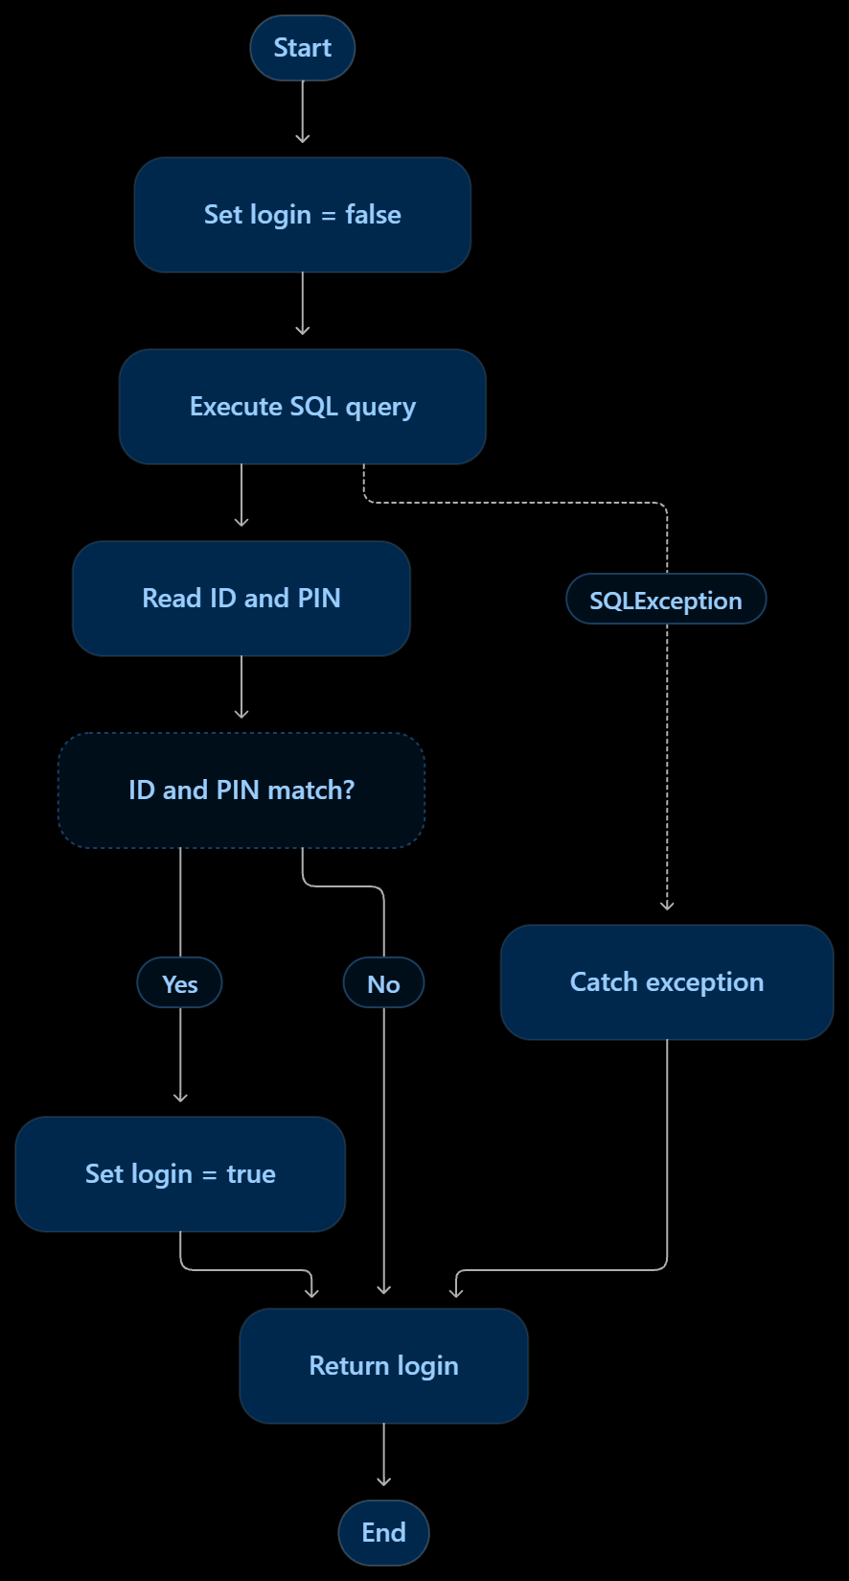
3.1.2 Cyclomatic Complexity
V(G) = Number of decisions + 1 therefore V(G) = 1 + 1 = 2
Where there are two independent normal execution paths
- ID and PIN match
- ID and PIN do not match
3.1.3 Test Cases
Test | Input | Expected Result
TC-01 | Existing ID and correct PIN | true
TC-02 | Existing ID and incorrect PIN | false
TC-03 | Non-existing ID | false
TC-04 | Database SQL exception | false
3.1.4 Variable Definition-Use Analysis
Variable | Definition | Use
login | Initialized to false; may be changed to true | Returned at the end
id | Method parameter | Used in SQL query and ID comparison
pin | Method parameter | Used in PIN comparison
ID | Retrieved from database | Compared with id
PIN | Retrieved from database | Compared with pin
database | Method parameter | Used to execute the SQL query
3.2 Method Two: TransactionsDatabase.getUserTransactions()
3.2.1 Control Flow Graph
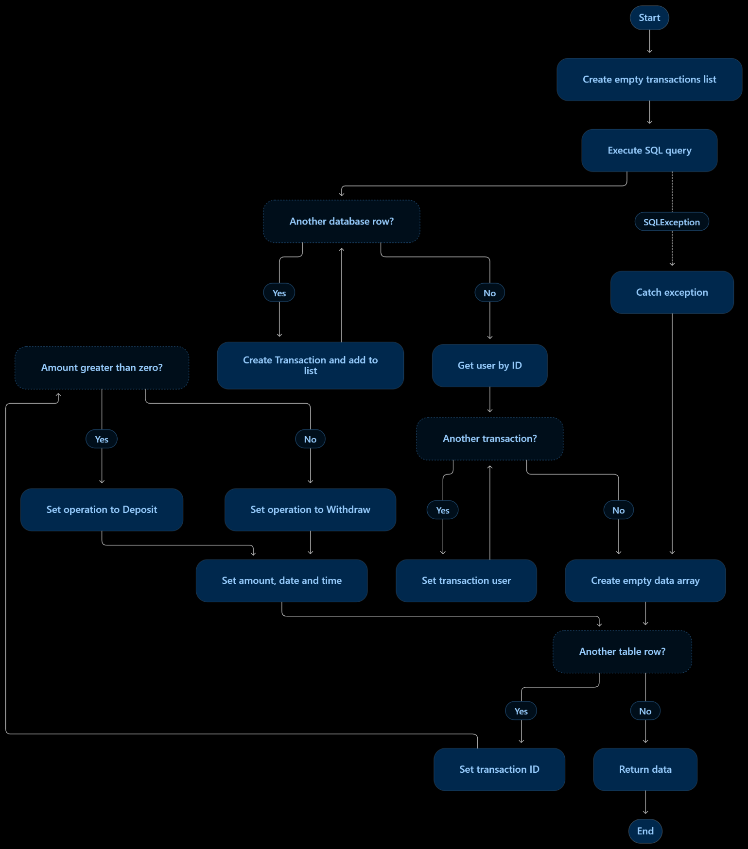
3.2.2 Cyclomatic Complexity
V(G) = Number of decisions + 1 therefore V(G) = 4 + 1 = 5
Where there are five independent normal execution paths
- User has no transactions
- User has one positive transaction
- User has one negative transaction
- User has multiple transactions
- Database query throws an SQL exception
3.2.3 Test Cases
Test | Input | Expected Result
TC-05 | User with no transactions | Empty two-dimensional array
TC-06 | User with a transaction amount of +100 | Operation displayed as Deposit, amount 100
TC-07 | User with a transaction amount of -50 | Operation displayed as Withdraw, amount 50
TC-08 | User with multiple positive and negative transactions | All transactions displayed correctly
TC-09 | Database SQL exception | Exception handled without crashing this method
3.2.4 Variable Definition-Use Analysis
Variable | Definition | Use
transactions | Initialized as an empty list | Stores and processes retrieved transactions
select | SQL query is assigned | Used in database execution
rs | Result of SQL query | Used in rs.next() and retrieving database values
t | New transaction object | Used to store transaction information
user | Retrieved using getUserByID() | Assigned to each transaction
data | Created as a two-dimensional array | Stores the final table information and is returned
j | Initialized to zero in the loop | Used as the table row index and incremented

3.3 Statement and Branch Coverage
3.3.1 Statement coverage
Measures how many executable statements are executed during testing
$$Statement Coverage=\frac{Executed Statements}{Total Statements}×100$$
3.3.2 Branch coverage
Measures how many possible decision outcomes are executed during testing
$$Branch Coverage=\frac{Executed Branches}{Total Branches}×100$$

Method | Decision | Possible outcomes
Login() | ID and PIN match | True / False
getUserTransactions() | Database row exists | True / False
getUserTransactions() | Another transaction exists | True / False
getUserTransactions() | Another table row exists | True / False
getUserTransactions() | Amount greater than zero | True / False

Method | Statement coverage target | Branch coverage target
Login() | 80% | 80%
getUserTransactions() | 80% | 80%
Combined | 80% | 80%

